BIOL 772/872 M&S in Life Sciences

Lab 5 Name: Amanda DeVleeschower

1. Link for ggplot tutorials.
   1. <http://r-statistics.co/Complete-Ggplot2-Tutorial-Part1-With-R-Code.html>
   2. Try making the plots shown on new data set
   3. Export 3 plots of your data and insert those images here.

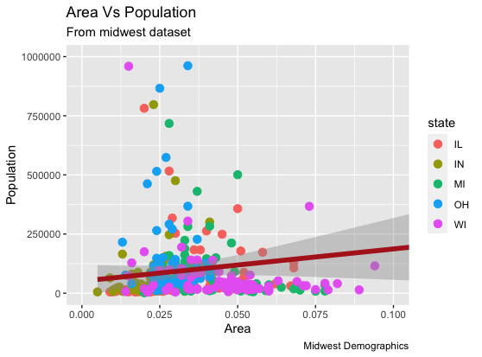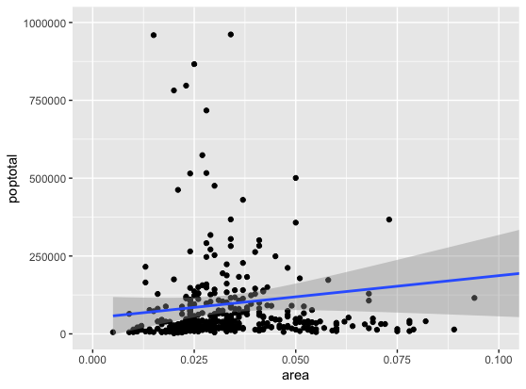

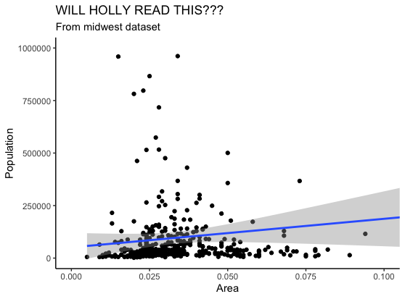

1. Add a third country to our COVID model.
   1. Copy R code here.
   2. Create one plot of Infected population in each country.

rm(list=ls())

require(deSolve)

#----- The differential equations -----

sir <- function(t, x, p) {

with(as.list(c(x,p)),{

#Country 1

dS_1 <- -S_1*(beta*(I_1+A_1)+m12*beta*(I_2+A_2)) - nu_1*S_1 + w1*V_1 + w2*R_1

dE_1 <- S_1*(beta*(I_1+A_1)+m12*beta*(I_2+A_2)) - e*E_1

dA_1 <- mu1*e*E_1 - nu_1*A_1 - gamma1*A_1

dI_1 <- (1-mu1-mu2)*e*E_1 - gamma2*I_1 - phi*I_1 - delta1*I_1

dH_1 <- mu2*e*E_1 + phi*I_1 - gamma3*H_1 - delta2*H_1

dR_1 <- gamma1*A_1 + gamma2*I_1 + gamma3*H_1 - nu_1*R_1 - w2*R_1

dV_1 <- nu_1*S_1 + nu_1*A_1 + nu_1*R_1- w1*V_1

#Country 2

dS_2 <- -S_2*(beta*(I_2+A_2)+m21*beta*(I_1+A_1)) - nu_2*S_2 + w1*V_2 + w2*R_2

dE_2 <- S_2*(beta*(I_2+A_2)+m21*beta*(I_1+A_1)) - e*E_2

dA_2 <- mu1*e*E_2 - nu_2*A_2 - gamma1*A_2

dI_2 <- (1-mu1-mu2)*e*E_2 - gamma2*I_2 - phi*I_2 - delta1*I_2

dH_2 <- mu2*e*E_2 + phi*I_2 - gamma3*H_2 - delta2*H_2

dR_2 <- gamma1*A_2 + gamma2*I_2 + gamma3*H_2 - nu_2*R_2 - w2*R_2

dV_2 <- nu_2*S_2 + nu_2*A_2 + nu_2*R_2 - w1*V_2

#Country 3

dS_3 <- -S_3*(beta*(I_3+A_3)+m31*beta*(I_1+A_1)) - nu_3*S_3 + w1*V_3 + w2*R_1

dE_3 <- S_3*(beta*(I_3+A_3)+m31*beta*(I_1+A_1)) - e*E_3

dA_3 <- mu1*e*E_3 - nu_3*A_3 - gamma1*A_3

dI_3 <- (1-mu1-mu3)*e*E_3 - gamma2*I_3 - phi*I_3 - delta1*I_3

dH_3 <- mu3*e*E_3 + phi*I_3 - gamma3*H_3 - delta2*H_3

dR_3 <- gamma1*A_3 + gamma2*I_3 + gamma3*H_3 - nu_3*R_3 - w3*R_3

dV_3 <- nu_3*S_3 + nu_3*A_3 + nu_3*R_3 - w1*V_3

list(c(

dS_1, dE_1, dA_1, dI_1, dH_1, dR_1, dV_1,

dS_2, dE_2, dA_2, dI_2, dH_2, dR_2, dV_2,

dS_3, dE_3, dA_3, dI_3, dH_3, dR_3, dV_3

))

})

}

beta = 0.00005

nu_1 = 0.0 # no vaccination in location 1

nu_2 = 0.001

nu_3 = 0.001

w1 = 1/90 # assuming vaccine immunity lasts for 90 days

w2 = 1/180 # assuming natural immunity lasts for 180 days

w3 = 1/180 #assuming immunity lasts for 180 days

e = 1/10 # 10 days from exposure to infection

mu1 = 0.25 # percent asymptomatic 15-60% from various sources

mu2 = 0.0002 # percent to hospital from CDC data from Sept 29, 2022

mu3 = 0.0002

gamma1 = 1/9 # guessing same as mild case or less

gamma2 = 1/10 # sick for 7-14 days

gamma3 = 1/50 # sick for 6 weeks or more

phi = 0.00004 # guessing part of hospitalized rates are from here

delta1 = 0.0

delta2 = 0.011/50 # case-fatality divided by length of infection

delta3= 0.0

m12 = 0.0

m21 = 0.0

m31 = 0.0

S_0 <- 5000.0 # Initial conditions

E_0 <- 0.0

A_0 <- 0.0

I_0 <- 5.0 # initial conditions

H_0 <- 0.0

R_0 <- 0.0 # initial conditions

V_0 <- 0.0

times <- seq(0.0, 1000.0, 0.1) # Time sequence

parms <- c(beta=beta, nu_1=nu_1, nu_2=nu_2, w1=w1, w2=w2, e=e,

mu1=mu1, mu2=mu2, mu3= mu3, gamma1=gamma1, gamma2=gamma2,

gamma3=gamma3, phi=phi, delta1=delta1, delta2=delta2, delta3=delta3,

m12=m12, m21=m21, m31=m31

)

xstart <- c(S_1=S_0, E_1=E_0, A_1=A_0, I_1=I_0, H_1=H_0, R_1= R_0, V_1=V_0,

S_2=S_0, E_2=E_0, A_2=A_0, I_2=I_0, H_2=H_0, R_2= R_0, V_2=V_0,

S_3=S_0, E_3=E_0,A_3=A_0, I_3=I_0, H_3=H_0, R_3=R_0, V_3=V_0) # Initial conditions

my.atol <- c(1e-16,1e-16,1e-16,1e-16,1e-16,1e-16,1e-16,

1e-16,1e-16,1e-16,1e-16,1e-16,1e-16,1e-16,

1e-16,1e-16,1e-16,1e-16,1e-16,1e-16,1e-16); # Abs. accuracy - remember to add a term for each equation

my.rtol <- 1e-12 # Rel. accuracy

out <- as.data.frame(lsoda(xstart, times,

sir, parms, my.rtol, my.atol)) # Solve the eqns.

#----- Plot the output -------

plot(out$time, out$I_1, col="black", type="l", lwd=5,

xlab="Time", ylab="Number")

#ylim=c(0,5000), xlab="Time", ylab="Number")

lines(out$time, out$I_2, col="red", lwd=5)

lines(out$time, out$I_3, col="blue", lwd=5)

#lines(out$time, out$R, col="blue", lwd=5)

grid(NULL, NULL, lty=1,lwd=1)

